Artificial Intelligence for Simulation

# Introduction

The objectives of this coursework were to be able to create and implement a simple AI software system and to understand how the AI works. To do this, the task given was to create an artificially intelligent tank to fight other artificially intelligent tanks in a battle royal type of game. We were told to organise ourselves in groups of 5 or 6, which for us, was easy to do due to our previous collaboration work in first year.

We decided very early on that we would like to be efficient with this project. We created a Discord group to be able to converse with one another and to be able to host meetings. We then created our repository on GitHub thanks to Oskar to be able to easily collaborate with each other and to be able to push changes to the projects with many problems.

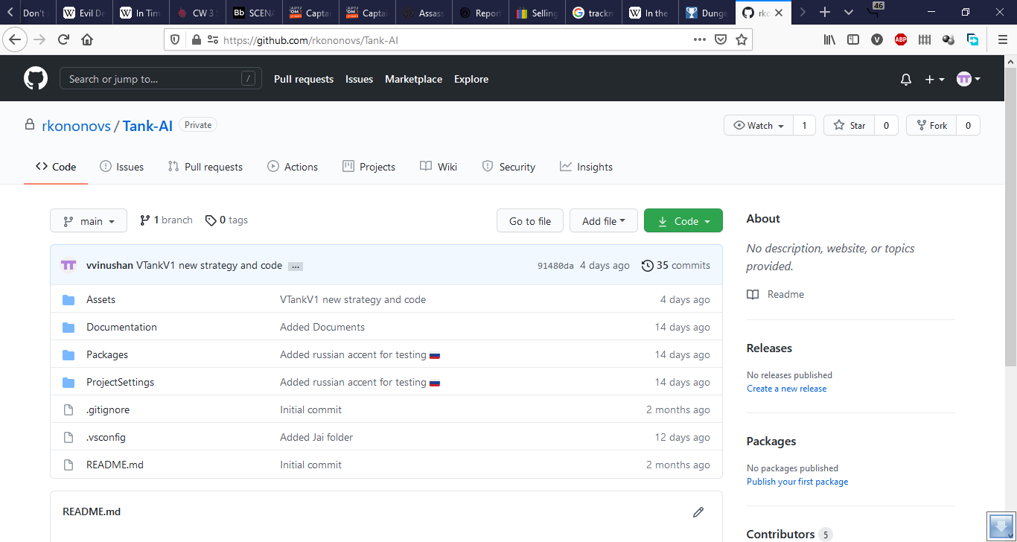

Next, we went with Romans idea of using Trello so we set up a Trello page where we could add tasks that needed to be done, assign people to those tasks to keep track of who has done what, check any changes that needed to be done as well as check the progression of the project. All these tools allowed the group to be as efficient and effective as possible whilst keeping disruptions and problems down considerably. This was all discussed in our first group meeting where we also discussed the questions featured in lecture 21b.

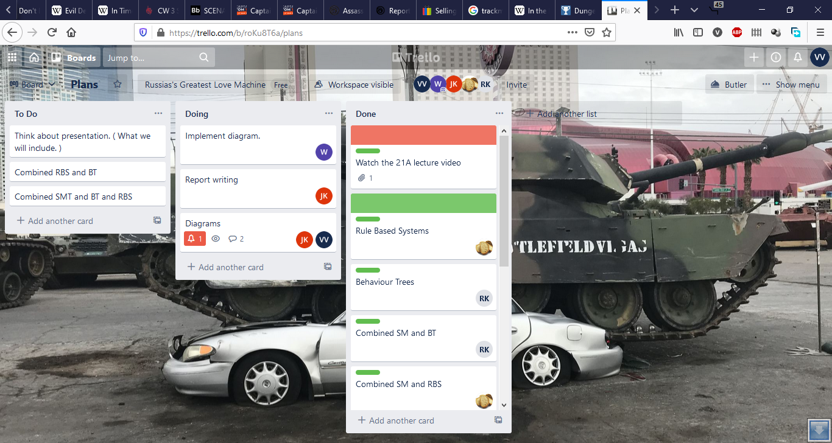

# Team Name and Roles

Once we formed the group, our first week was dedicated into creating the tools mentioned above. We had to decide on a group name and roles. Whilst on our first meeting call on Discord, we were throwing out names to see what everyone liked until Jai mentioned Russia’s Greatest Love Machine. Everyone enjoyed the idea of the tank being Russian, and so the name of the team was set. Next, we decided on roles for the group. As the two strongest C# coders in the group, Oskar and Romans were given the roles of lead programmers with the rest of the group to assist them where necessary. Artur was given the role of tester and programmer helper. Jai was made the project manager to look over all the roles and was given the duty of creating the documentation. Vinushan was originally given the documentation role but after Jai was given the task, Vinushan began focusing on strategy for the tank. He was also taking down minutes for our meeting and after the project had been completed, Vinushan once again took over the role of documentation to finish the remainder that could not be completed by Jai due to unforeseen circumstances. With the roles sorted, we started by creating the repository and allowing all of us to publish to it. Next, we set up the first couple of to dos in the Trello page and assigned everyone to watch all the lecture. We also decided then that a group meeting should be held roughly biweekly with more meetings closer to the deadline. We also gave ourselves an early deadline so that if any problems were to arise, we would have time to solve them.

In addition, we decided to incorporate the extreme programming methodology with a few changes, notably the frequency of meetings. As mentioned before, we decided on holding biweekly meetings with increasingly closer meetings towards the deadline. While we did not have daily meetings throughout the whole project, the group still caught up and kept everyone apprised of their situation with the project on the Discord server text channels. It was also suggested about that Romans and Oskar would engage in pair programming. Before we came to a decision about the methodology, the group also explored options such as the Kanban programming standard but ultimately concluded that extreme programming is the best way forward.

Future meetings were organised in large part by Jai as the group leader, and this included setting the agenda for the group to give an progress update on each of their respective roles.

# State Machine

Once the lecture was released and everyone had had their lab session on finite state machines, we had a meeting to start to implement this in our AI. We first planned multiple strategies.

*[PICTURES OF REJECTED FLOW CHARTS]

*[PICTURE OF FINAL FLOW CHART]

This final flow diagram is one we as a group decided was the best for our strategy for our tank. This allowed us to see the number of states we would need and how to implement them as well as think about how to implement the rest of the diagram as code.

Oskar took lead on this creating most of the code for the state machine. The first was the virtual base class BaseState. This class has 3 functions that all abstract and would be overridden in classes that inherited from the class. Next, the StateMachine.cs script was written. The state machine can take all the states that are created and adds them to an internal private dictionary to be looked up when called. It can set the state of the tank, get the state the tank is in, and change the state of the tank.

# Rule Based System

*Oskar also took the lead on implementing Rule Based System.

# RGLM Tank

Oskar was mainly responsible for inspiring the rest of the group on the tank design when he made the new texture in surface painter. It underwent some changes but the main idea that the group wanted was to see a Russian themed tank, so that it would suit the group’s namesake, and then it was implemented in the RGLM tank.

*[PICTURES OF REJECTED DESIGNS]

*[PICTURES OF FINAL DESIGN]

All group members helped with the coding of this main AI tank. Oskar was in large part responsible for setting up the class and functions that will eventually be inherited and used by the group for the rest of the project. Many of the code that could not be modified used protected functions. This meant that these functions could not be accessed by other classes most of the time, so Oskar re-wrote and made all of the functions in the RGLM tank script which enabled the rest of the group members to use them in their states without any issues. He produced a pdf document of these functions to further assist the group. Oskar and Romans also created a function that rotated the tank by 360 degrees,

# Individual AI Tanks

Members of the group created their own separate AI tanks with a set of predetermined flowcharts showcasing the different strategies. We needed a set of AI tanks with different strategies to ensure that we can test to see how long each tank can survive in a survival setting. We used flowcharts created with the Lucidchart tool online to illustrate the AI strategies.

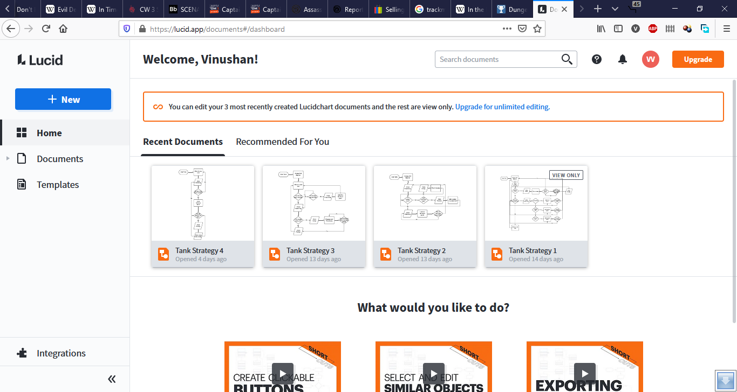

Jai created a strategy and began implementing his JTankV1 AI tank using state machine. His tank will begin by looking for consumables in the ‘Searching’ state and change to ‘Gathering’ state to collect any nearby consumable packs. If an enemy tank is near, it will enter the ‘Gulag’ state and start attacking. It will immediately switch to the ‘Fleeing’ state and move away to a new spot if resources are running low or the enemy is out of sight. This strategy ensures that the tank will only engage in combat when the enemy is in sight and will otherwise focus on survival to outlive the other enemy tanks. The primary goal of this AI is to maintain the resource levels and to flee as soon as one or more of the resource attributes are running low, which will increase the time at which this tank will stay alive in a survival setting.

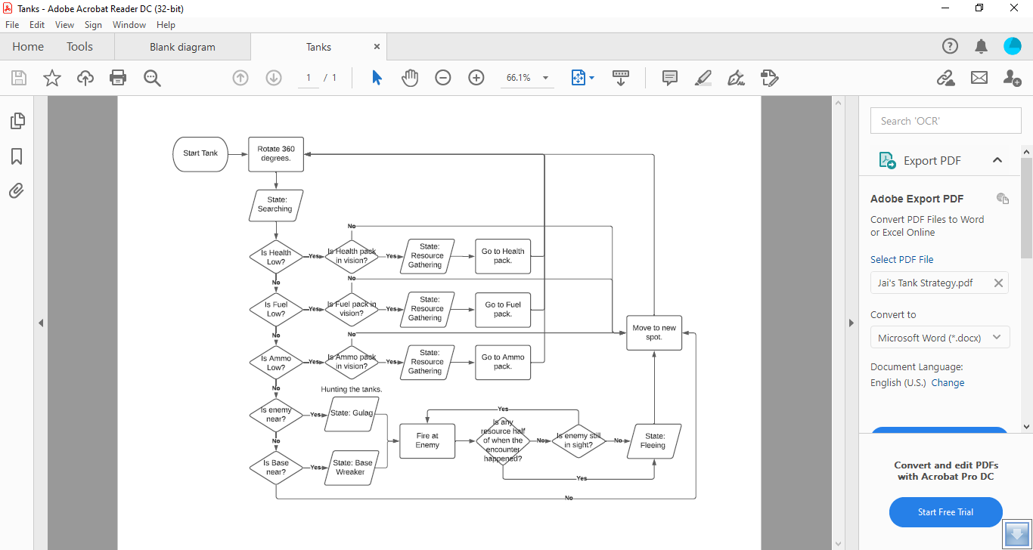

Vinushan initially created 3 strategies for potential use by group members and decided to use strategy 1 to implement his VTankV1 AI tank using state machine.

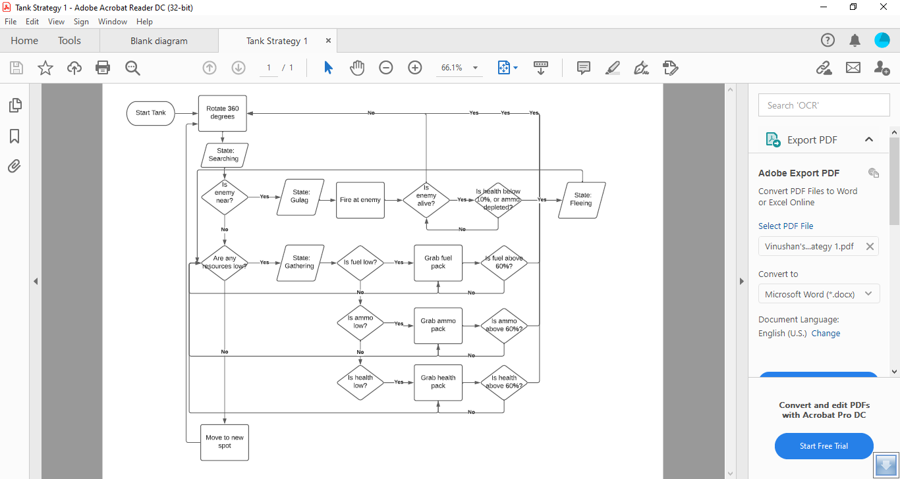

However, in practice, it became clear that this strategy is too similar to Jai’s AI and it was decided that Vinushan will create a new strategy with a completely different perspective on how to achieve victory. This was implemented using both state machine and rule based system. VTankV1 was redesigned to never stop moving, collecting resources where possible and running away from enemies at double speed if in proximity. At first the tank will always enter the ‘Searching’ state and continuously look for consumables, switching to ‘Gathering’ state to collect them when they are near. If an enemy is sighted, the tank will enter the ‘Fleeing’ state where it will move away to a new area at double the usual speed until the enemy is no longer near VTankV1 and the tank will return to the ‘Searching’ state. This strategy has the main aim of surviving longer than all of its enemy tanks by always replenishing resources regardless of the current levels and without ever engaging in combat.

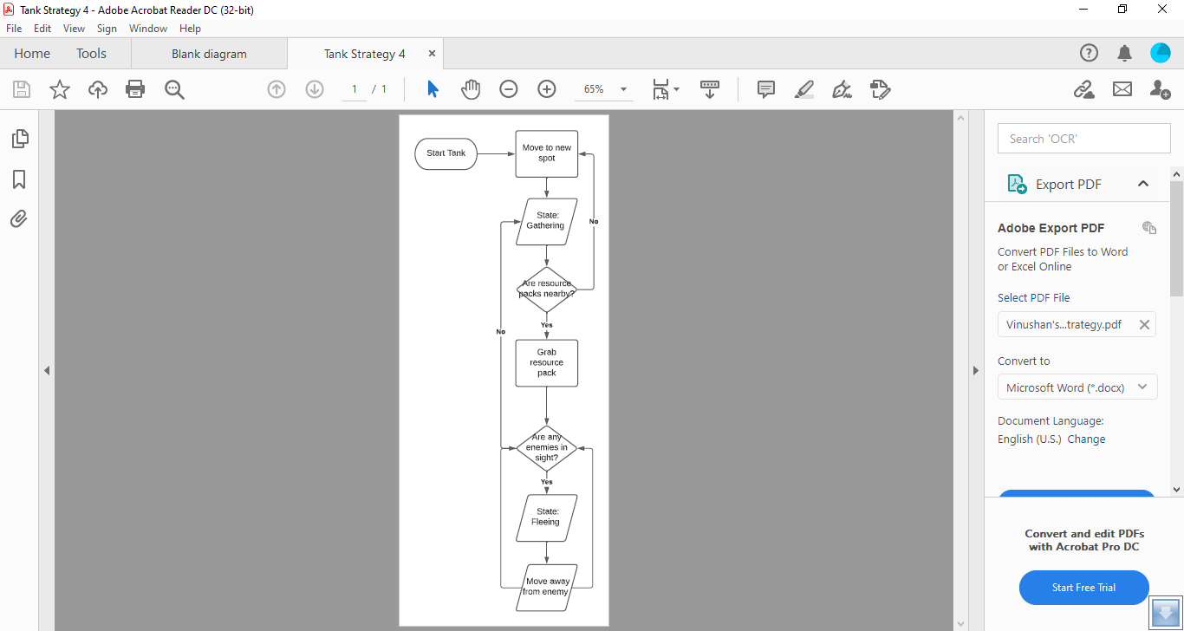

*Romans created both the BT (Sensor Simulation and Probability) tank and the state machine tank with a unique strategy.

[PICTURE OF STRATEGY FLOW CHART]

Oskar created a ‘lazy passive tank’ with state machine and rule based system. This tank is based on the approach of conserving resources and only moving if there is an enemy or consumables nearby. As it can be seen in the flow chart below, the tank takes a break almost always and it fulfils its namesake of being lazy where it will not engage in combat and focus on saving resources to be the last one standing.

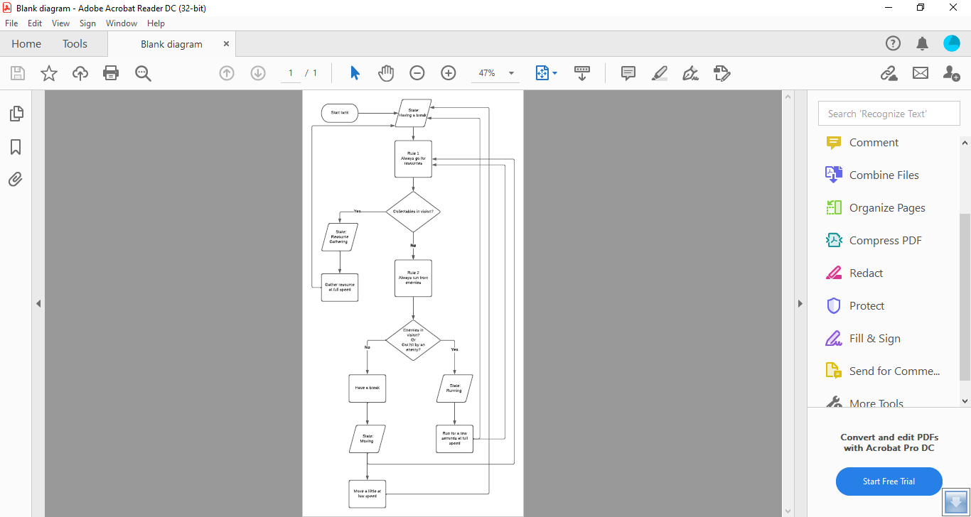

Suggestions were made for Artur to use one of Vinushan’s strategies for an AI tank but he ultimately assisted the group and tested all aspects of the project.

# Programming help

As the two lead programmers who had the most programming experience, Oskar and Romans created a separate voice channel in the Discord server titled ‘Help’. This was used by all members of the group when assistance was needed with scripts and strategies and usually featured one on one support for everyone’s roles. Romans and Vinushan spent most of the time programming in their own time.

Oskar provided a demo to all group members on how to access functions in the RGLM class in the state machines, and the programming standard to be used throughout the project.

# 

# Testing

All members of the group contributed to finding bugs in the code and testing out the tanks. Oskar is responsible for a majority of bug fixes, while Artur and Jai are responsible for majority testing of the tanks and creating the test table.

*[TEST TABLE]

# Conclusion

Towards the final week, the deadline was extended by an extra week which allowed more time to finish and improve the project. The group decided to use the previous deadline as a ‘soft deadline’ to finish all scripts and testing, with the following week being used for completing documentation and bug fixing. This allowed the group to be well prepared in advance and begin preparations on giving a presentation on the final version of this project.